- Purpose

The purpose of this document is to describe the specifications and design that will be implemented for the process of exporting data from ClearView.

- General Requirements

Where appropriate, logic should be contained in try/catch blocks and any exceptions should be logged using the standard logging mechanisms.

- Specifications

Requirement #1: This functionality should only be available to administrators.

Specification: The export button which is the only way to initiate the export process is controlled by the login. The button only appears for the built in user administrator. All other logins will result in the button being hidden from view.
In addition the all other export functionality that was embedded in the administration pages has been removed. The only way to export data intrinsically from the system is to use the button.

Requirement #2: Add a button to the Capture Search Results dialog that can be used to start an export of a subject's data.

Specification: A button labeled “Export Data” has been added to the Capture Search window. The button will initiate the export process for the row that has been selected in the grid. The button appears in the lower left corner of the search results dialog.

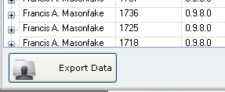
The button will only appear for the user 'administrator'.

Requirement #3: A button should appear for each search results row that appears in the Capture Search Results dialog.'

Specification: Since the export process is a singleton function (can only run one at a time) it did not make sense to have resources wasted by placing a button on each row of the search results. In addition, this would break the paradigm already established for other buttons in the system.
The button was implemented at the bottom of the search results form in the same manner as the existing functionality of the app.
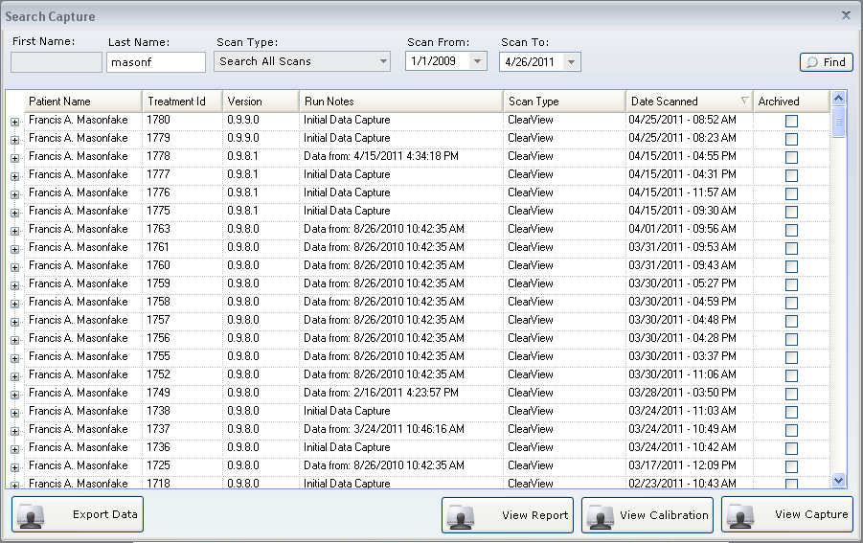

Requirement #4: The export process should allow the exporter to choose the destination location for the files to be saved.

Specification: When the user clicks on the Export Data button, the process that is initiated will display a dialog prompting the user for the folder that the data should be exported into.
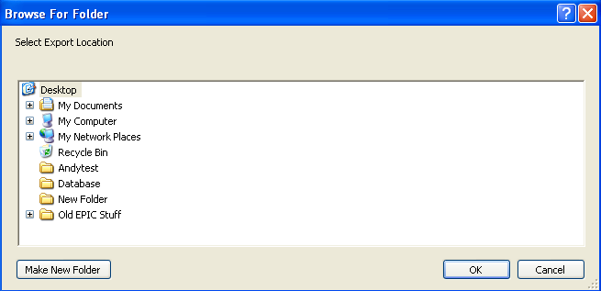
The user can select any folder that they have access to including network folders. Once the destination folder is selected, the user will click the 'OK' button to continue the export process. The folder selected will be the base location where the specified folder structure will be created containing the selected data.

Requirement #5: The base folder that should be created for the export will follow this naming convention: {Subject Id}_Date and time of scan.

Specification: After the base folder a root folder for the subject being exported will be created. The name of the folder will consist of the LastName field for the user (which is being used to hold the subject id), with the date and time of the scan appended. An example of the folder would be:
RPT-1234343_10_20_2011_11_55_38_PM

Requirement #6: The process should export the following for the given scan that was selected.

- Calibration Images
- Energized Images (Filtered and Unfiltered)
- Finger Images (Filtered and Unfiltered, if available)
- The raw data for the calculation (in csv format)
- The report data

Specification: The calibration images are being exported, they are pulled from the database and exported in exactly the same format as they were captured, not loss of quality is realized.
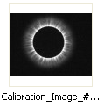
The energized images are extracted from the database and saved in the exact same format and resolution as they were captured.
The finger images (if they are available) are extracted from the database and saved in the exact same format and resolution as they were captured. In the case where the images are not available, the folder will be blank.
The raw data from the system (calculations) is being extracted into an excel formatted file named 'RawData.xls'.
The final report data is being extracted into an excel formatted file called 'ReportData.xls'.
Addition, not called out in requirements: The Calibration data (calculations performed by the system) is being exported into a csv formatted file called 'CalibrationData.csv'.

Requirement #7: Within the folder selected, create the following folder directory structure:
\CalibrationImages
\FingerImages
\EnergizedImages
\RawData
\ReportData

Specification: The folder structure outlined above is automatically created at the time ow export in the base folder described in requirement #5. An additional folder was added to accommodate the Calibration Data export that was added. The created structure is illustrated below:
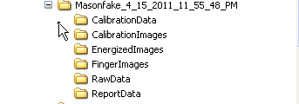
Requirement #8: Clicking the button should cause the following actions.
- Display the output directory selection dialog
- Export the data into the folder selected
- Display a completion confirmation dialog.

Specification: When the export button is clicked, a dialog appears prompting the user for the root location for where the export data should be placed. Upon successful selection of a root folder, the system will create the necessary folder structure and export the relevant data. Once the data has been exported, a confirmation dialog will appear alerting the user that the process has been completed.

Document Revision History
Version Number: | Description of Change: | Date: | Updated by:
000 | Introduction | 5/24/11 | A. Mason

